**ASSIGNMENT 08**

1. DROPLET DEFORMATION IN AN ELECTRIC FIELD:

Video description: A blue-dyed water droplet in highly viscous castor oil, placed in a rectangular cuvette with parallel electrodes 2 cm apart, undergoes deformation under a 3 kV DC electric field. The intense field induces Maxwell stress at the droplet–medium interface, prompting the droplet’s deformation.

Name of the video: “ehd.mp3”

Task 1: Fit and plot elliptical contour around the droplet.

Task 2: Find out the deformation vs. time plot.

Deformation =

Hints: Follows the first-class room problem “Air expelling from a balloon”

1. Using OpenCV in Python, develop a method to measure and calculate the cross-sectional areas of different structures in an umbilical cord histology image stained with Hematoxylin and Eosin (H&E). The cross-sectional areas to measure include:

1. Umbilical vein lumen (UVL)

2. Umbilical vein wall (UVW)

3. Umbilical artery lumens (UAL1 and UAL2)

4. Umbilical artery walls (UAW1 and UAW2)

5. Wharton’s Jelly cross-sectional area (WJ-CSA), which is calculated according to the histomorphometry section

Image name: “umbilical-cord.png”

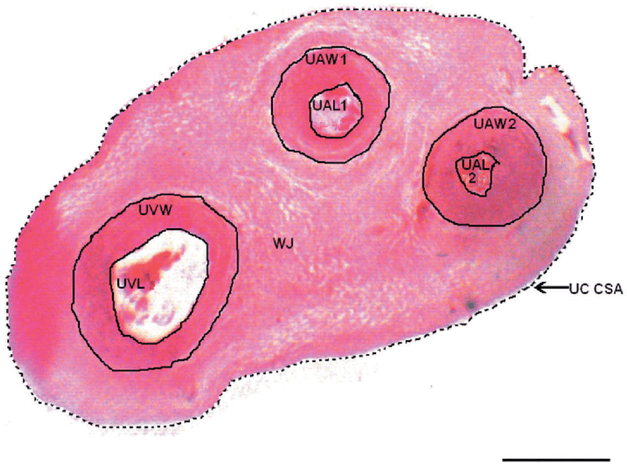 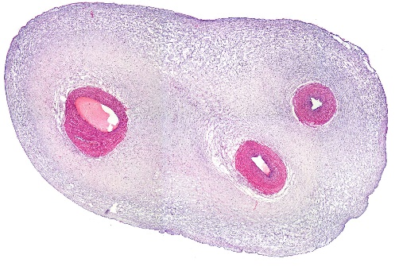

Schematic for measuring eight cross-sectional areas of an umbilical cord (UC-CSA). H&E stain. Areas are umbilical vein lumen (UVL), umbilical vein wall (UVW), umbilical artery lumens (UAL1 and UAL2) and umbilical artery wall (UAW1 and UAW2). Umbilical cord (UC-CSA) measured is surrounded by dotted black line (black arrow). All other areas measured are outlined with a solid black line. The calculation for Wharton's Jelly cross-section area (WJ-CSA) is found in histomorphometry section. Scale bar = 2 mm.

In the provided image:

The umbilical cord cross-sectional area (UC-CSA) is outlined with a dotted black line and marked with a black arrow. All other areas are outlined with solid black lines.

Use OpenCV to:

1. Identify and outline each area.

2. Calculate each region’s cross-sectional area.

3. Report the UC-CSA and each individual area, including the Wharton’s Jelly area as specified.

Hint: The scale bar in the image is 2 mm, which you should use to calibrate measurements.

1. CAPILLARY FILLING

Video description : The video illustrates the capillary filling process in a resin-printed chip with three channels of equal diameter but varying depths. A low-viscosity red dye is introduced into one of the chip’s reservoirs, initiating the capillary action in each channel. The rate at which the dye fills each channel varies, influenced by the differing channel depths, which, in turn, result in different hydraulic diameters. This variation in hydraulic diameter affects the capillary length, which is determined by the surface tension, fluid density, and channel dimensions. Additionally, a precursor flow precedes the bulk fluid filling in each channel due to the influence of the channel's curvature. This precursor flow highlights the intricate interplay between channel geometry and fluid dynamics in capillary action.

Video name: “Capillary_filling.mp4”

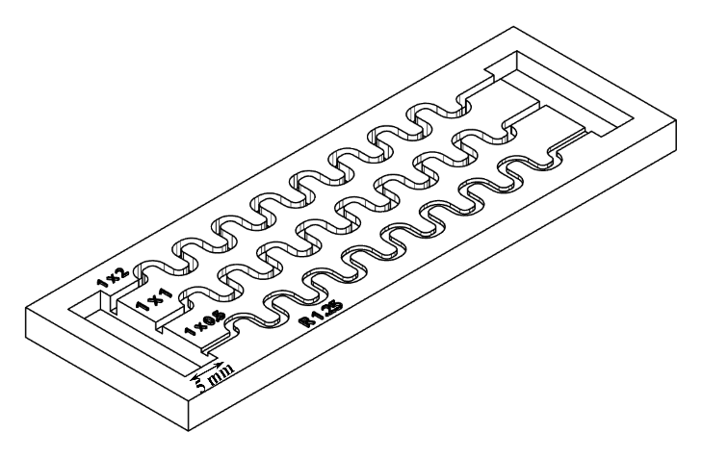

The schematic represents the channel where all the dimension are in mm.

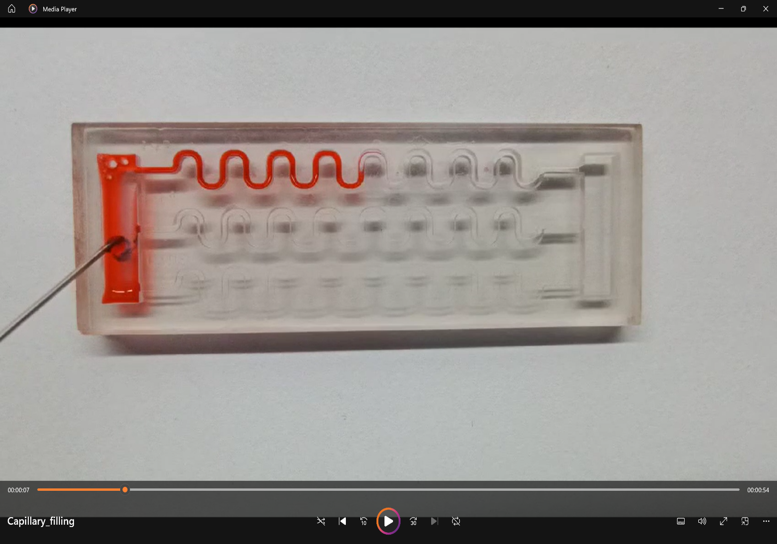

The capillary filling of the dye in the channel where there is mean bulk fluid filling and a precursor film is flowing exceeding the bulk fluid film.

Task 01: Plot the distance travelled by fluid in each channel with respect to the time.

Task 02: Find out for each channel how fast the precursor film moves in comparison to the bulk fluid film.